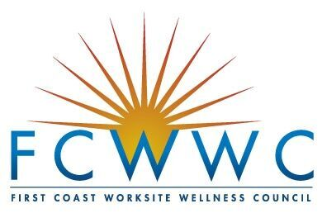

2018 Frank Barker Wellness Leader Award

Nominator application
Recognizing the efforts of wellness leaders for a healthier community

The First Coast Worksite Wellness Council (FCWWC) seeks to recognize leadership in local wellness professionals (including, but not limited to):

Wellness Directors, Managers, Coordinators

Human Resources and Benefit Professionals

Nominations should only come from individuals who know their candidate well and who are personally inspired by them. The nominator must complete this form for their nominee to be considered. A candidate may not solely nominate themselves. All nominations should be submitted to awards@firstcoastwwc.org by March 23, 2018.
Date:

NOMINEE information
Name:
Company:
Title:
Email:
Phone:

NOMINATOR information
Name: Company: Title: Email: Phone:

Nomination Instructions

in approximately 300 -600 words, explain the nominated wellness leaders’ personal characteristics, exemplary work and demonstrated outcomes that qualify them to receive this award. Please address at least 3 of the qualities listed below in your response.

Passion - Nominee demonstrates dedication and devotion to improve worksite wellness.
Inspiration - Spread encouragement and enthusiasm are spread to their colleagues and employees in their program.
Empathy, Care & Commitment - Concern for people and well-being drives them to improve health outcomes and improve quality of life.
Adaptability - Overcame a barrier in their program (such as a policy changes, population of group, culture of workforce).
Sustainable Impact - Facilitated substantial measurable improvements in health and/or behavior change within organization(s).
Demonstrated Leadership - Provided guidance and influence to enhance healthy cultures in the workplace and in the community.
Combine Ideas & Action - Has taken an idea and developed it into an actionable plan/ program that has made a difference at their organization or within the wellness community.

Briefly explain your relationship to the nominee:

I, the nominator, hereby certify that:

- All the statements I have provided are true and correct.
- I have the permission of the nominee to nominate them.
- I am not member of the FCWWC Board of Governors or an employee of a company represented on the FCWWC Board.

To certify these statements, please print your name and date:

Name:

Date:

