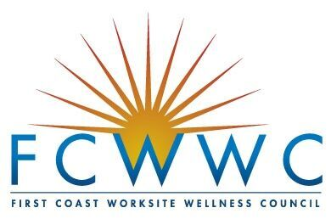
2017 Frank Barker Wellness Leader Award

Nominee application
Recognizing the efforts of wellness leaders for a healthier community

The First Coast Worksite Wellness Council (FCWWC) seeks to recognize leadership in local wellness professionals (including, but not limited to):

Wellness Directors, Managers, Coordinators

Human Resources and Benefit Professionals

Nominees for this award should be involved in the implementation, design and/or measurement of a worksite wellness program. The corresponding nominator should know their candidate well and be inspired by the nominee’s work. A candidate may not solely nominate themselves – the nominator and nominee forms must both be completed for consideration. All nominations should be submitted to awards@firstcoastwwc.org by April 7, 2017.
Date:

NOMINEE information
Name: Company: Title: Email Address: Phone Number:

Please provide the name, company, email and phone number for two appropriate references, excluding family members and the nominator.

Nominee Certification

In approximately 300 – 600 words, provide a personal statement about your work’s impact on employee/community wellness and well-being. describe what you have achieved, how you’ve demonstrated outcomes, and what you hope to achieve in the future.

I, the nominee, hereby certify that

- All the statements I have provided are true and correct.
- I have been working to improve wellness for at least three years.
- I live/work in the First Coast area. (Baker, Clay, Duval, Nassau or St. Johns County)
- I am not a member of the FCWWC Board of Governors.
- I am a current member of the FCWWC.
- I understand that I must be in attendance of the 9th Annual FCWWC Conference held at UNF on May 10, 2017.
- I have agreed to be nominated.
- If I am the recipient of this award, I will apply the financial portion of the award to support my organization’s worksite wellness initiatives, advance the promotion of health and well-being in the community, and/or increase my personal development and knowledge in the wellness field via continuing education programs, including events sponsored and hosted by the FCWWC.

To certify these statements, please enter your name and date:

Name:

Date:

